**Data Communication And Networking**

**Date:05.03.21**

**Name: RAJUL DUBEY**

**SAP ID: 500069424**

**ROLLNo.: R171218081**

**Task:** Configuring DHCP Server across the network

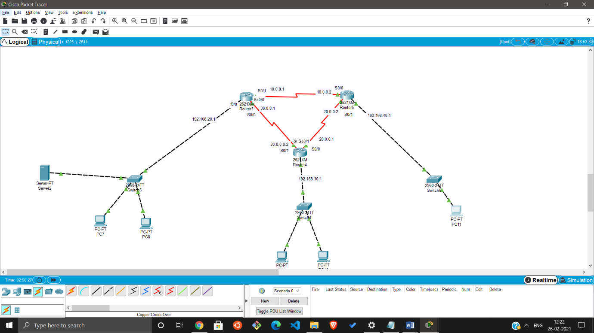

**Device Requirements:**

**Router 3,Server 1,swtiches 3, pcs n**

Router3 is 1st Router4 is 2nd Router5 is 3rd

For picture above

**Step 1:**Connect all 3 routers with Serial DCE cable

As shown in the picture

**Step 2:** Connect one Switch to each router’s f0/0 (optional)

**Step 3:** Now connect a **Server** to the switch of router3 (1st router)

Through a FastEathernet Interface

**Step 4:** Connect Pcs to the Switches of each router

**Step 5:** Now configure router3 to stablish connection b/w router4 and router5 and FastEthernet 0 for switch

Through Router’s CLI

**Commands:**

//For fasteathernet 0

en

conf t

int f0/0

ip add 192.168.20.1255.255.255.0

no shut

exit

**//for Serial 0**

int s0/0

ip add 30.0.0.1 255.0.0.0

clock rate 128000 (if you only connect first in this router)

no shut

exit

**for serial 1**

int s0/1

ip add 10.0.0.1 255.0.0.0

clock rate 128000 (if you only connect first in this router)

no shut

exit

**Step 6:** Now configure router4 to stablish connection b/w router3 and router5 and FastEthernet 0 for switch

Through Router’s CLI

**Commands:**

//For fasteathernet 0

en

conf t

int f0/0

ip add 192.168.30.1255.255.255.0

no shut

exit

**//for Serial 0**

int s0/0

ip add 20.0.0.1 255.0.0.0

clock rate 128000 *(if you only connect first in this router)

no shut

exit

**for serial 1**

int s0/1

ip add 30.0.0.2 255.0.0.0

clock rate 128000 *(if you only connect first in this router)

no shut

exit

**Step 6:** Now configure router0 to stablish connection b/w router4 and router3 and FastEthernet 0 for switch

Through Router’s CLI

**Commands:**

//For fasteathernet 0

en

conf t

int f0/0

ip add 192.168.40.1255.255.255.0

no shut

exit

**//for Serial 0**

int s0/0

ip add 10.0.0.2 255.0.0.0

clock rate 128000 *(if you only connect first in this router)

no shut

exit

**for serial 1**

int s0/1

ip add 20.0.0.2 255.0.0.0

clock rate 128000 *(if you only connect first in this router)

no shut

exit

**Step 7:** Now configure the Server

Click on the Server

i.)

config->Global->setting

default gateway: 192.168.20.1

ii.)

config->FastEthernet0

Ip Configuration:

Static

Ipv4: 192.168.20.2

255.255.255.0

iii.) Services->DHCP->

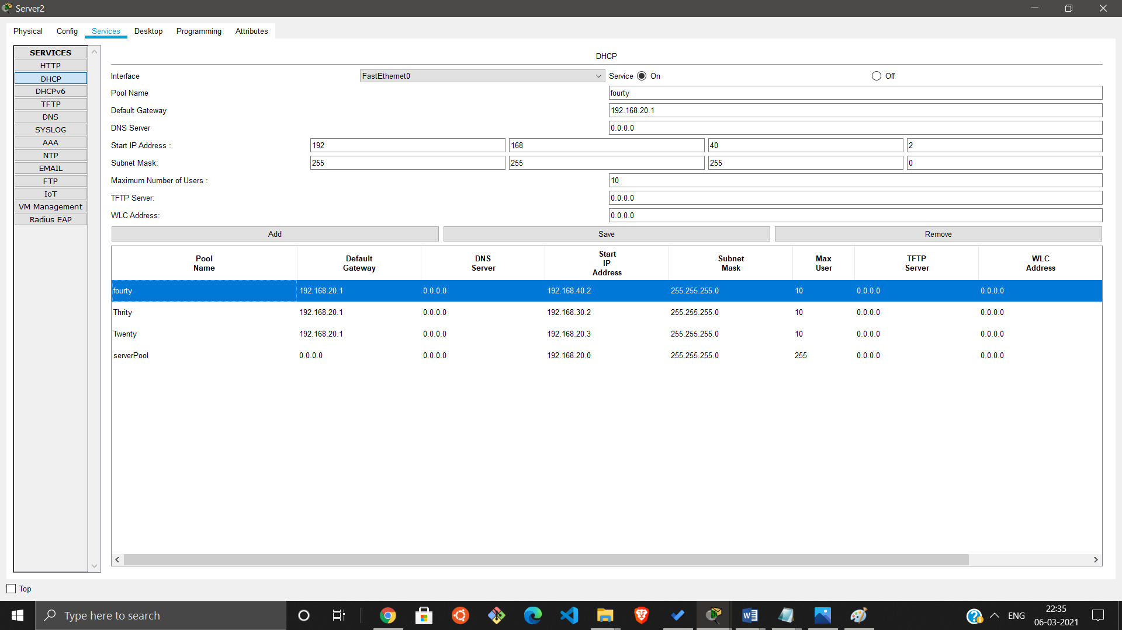

**Step 8:** Now Configure the routers to distribute ips in both switches

*Router’s CLI **(do this in all 3 routers)**

**Commans:**

**en**

**conf t**

**int f0/0**

**ip helper-address 192.168.20.2 (Server’s ip)**

**no shut**

**exit**

**Step 9:** Now configure RIP (Routing Information Protocol) **(do this in all 3 routers)**

Through Router’s CLI

**Commands:**

en

conf t

router rip

network 30.0.0.0

network 20.0.0.0

network 10.0.0.0

do wr

exit

**Step 10:**

Now go to any pc of any network and go to **IP Configuration**

And click on **DHCP**

Now your pc will get a ip Dynamically

